Experiment 18: Edge Detection using Sobel Matrix along Y axis
Software / Tools: Python · OpenCV (cv2)

AIM
To detect horizontal edges in an image using the Sobel operator along the Y direction.
ALGORITHM
1. Import OpenCV.
2. Read the image and convert it to grayscale.
3. Apply cv2.Sobel() with dx=0, dy=1 to compute the gradient along the Y axis.
4. Convert the result back to an 8-bit displayable image using cv2.convertScaleAbs().
5. Display and save the Sobel-Y edge image.
PROGRAM (SOURCE CODE)
import cv2

img = cv2.imread("image.jpg")
gray = cv2.cvtColor(img, cv2.COLOR_BGR2GRAY)

sobel_y = cv2.Sobel(gray, cv2.CV_64F, 0, 1, ksize=3)
sobel_y = cv2.convertScaleAbs(sobel_y)

cv2.imshow("Sobel Y", sobel_y)
cv2.waitKey(0)
cv2.destroyAllWindows()

OUTPUT
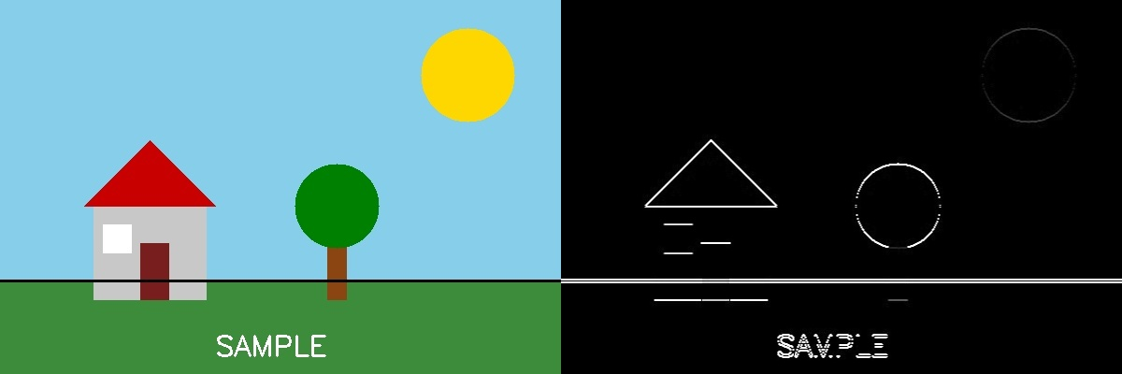
Fig. 18 — Output of Experiment 18: Edge Detection using Sobel Matrix along Y axis.
RESULT
Detect horizontal edges in an image using the Sobel operator along the Y direction — completed successfully, as demonstrated in the output shown above.

